⭐ PART 1 — Are the interfaces in java.sql and javax.sql?

✔ Yes, correct!
All JDBC interfaces are stored in two packages:

🟦 A) java.sql → Basic JDBC Package
These are the core JDBC interfaces that every database needs.
They include:
- Driver
- Connection
- Statement
- PreparedStatement
- CallableStatement
- ResultSet
- ResultSetMetaData
- DatabaseMetaData
These are required for:
- Connecting to database
- Sending SQL
- Getting results
- Reading data row-by-row

🧠 Easy way to remember
java.sql = basic JDBC operations
Everything needed for “normal JDBC coding”.

🟩 B) javax.sql → Advanced JDBC Package (Extensions)
These are advanced or enterprise-level interfaces.
They include:
- DataSource
- RowSet
- ConnectionPoolDataSource
- PooledConnection
- XADataSource
- RowSetListener
These are required for:
- Connection pooling
- Better resource management
- Working with Application Servers
- Distributed transactions (XA)
- Cached/disconnected data (RowSet)

🧠 Easy way to remember
javax.sql = advanced JDBC used in enterprise applications

⭐ PART 2 — Why are the names different? (java.sql vs javax.sql)
This is very important.
Let’s break it into simple points.

🟦 Reason 1 — java.* means core Java
Anything that is required by all Java programs goes into:
java.*
Examples:
- java.lang
- java.util
- java.sql
- java.io
So basic JDBC interfaces go into:
java.sql
because every Java application that uses database needs:
- Connection
- Statement
- ResultSet
These are core features.

⭐ Why javax.* originally meant Java Extension? (Deep Explanation)
When Java was first released (1995–1997), it had a small set of built-in packages:
- java.lang
- java.util
- java.io
- java.net
- java.sql
These were called the core Java packages.
But soon, developers needed extra features, such as:
- servlets for web applications
- email support
- security and encryption
- database pooling
- enterprise connectivity
Sun Microsystems did not want to directly add them into the core Java package (java.*).
So they created a new namespace:

👉 javax = Java Extension
The idea was:
“These are optional extensions that may or may not be used by everyone.”
So they created new packages:
- javax.servlet
- javax.mail
- javax.crypto
- javax.sql
- javax.transaction
- javax.activation
At that time, these were not part of the official JDK.
They were downloaded separately as add-ons.

⭐ Why did these extensions become part of standard Java later?
Java became huge.
Web development exploded.
Enterprise apps exploded.
Databases became essential.
That means:
- servlets became standard
- JDBC DataSource became standard
- XA transactions became standard
- encryption became standard
- email became standard
So javax.* packages became important for EVERY Java application.
So Sun added them into the official JDK, but:

🌟 They did NOT rename them to java.*
Because:
- It would break millions of existing Java applications
- Companies would lose years of code
- All frameworks like Spring, Hibernate, Struts, JSP would crash
- Recompiling or refactoring the entire Java ecosystem would be impossible
Java cares very strongly about:

🛡 Backward Compatibility

⭐ Backward Compatibility — The MOST important rule in Java
Backward compatibility means:
“Old Java programs should run exactly the same on new Java versions, without any code changes.”
Java is famous for this.
That’s why Java is used in:
- Banking
- Insurance
- Telecom
- Government
- Military systems
These systems cannot afford breakage.
If Sun renamed:
javax.sql → java.sql.advanced
javax.servlet → java.web.servlet
javax.mail → java.mail.api

All this would break instantly:
- Spring Framework
- Hibernate
- Struts
- Tomcat
It’s impossible to update so many systems.
So Sun/Oracle decided:

👉 “Do NOT rename the javax packages. Keep them forever.”
- Even if the package is no longer an extension,
the name remains for life.

Simple Real-Life Analogy (You will never forget)
Think of java.sql as a basic mobile phone.
- It can call
- It can text
- It can store contacts
This is all you need for simple use.
Now think of javax.sql as a smartphone.
- Apps
- Wi-Fi
- Internet banking
- Payments
- High-level features
This is needed for big workloads.
Both are phones.
But one is basic, the other is advanced.
Same way:
- java.sql → basic JDBC
- javax.sql → advanced JDBC

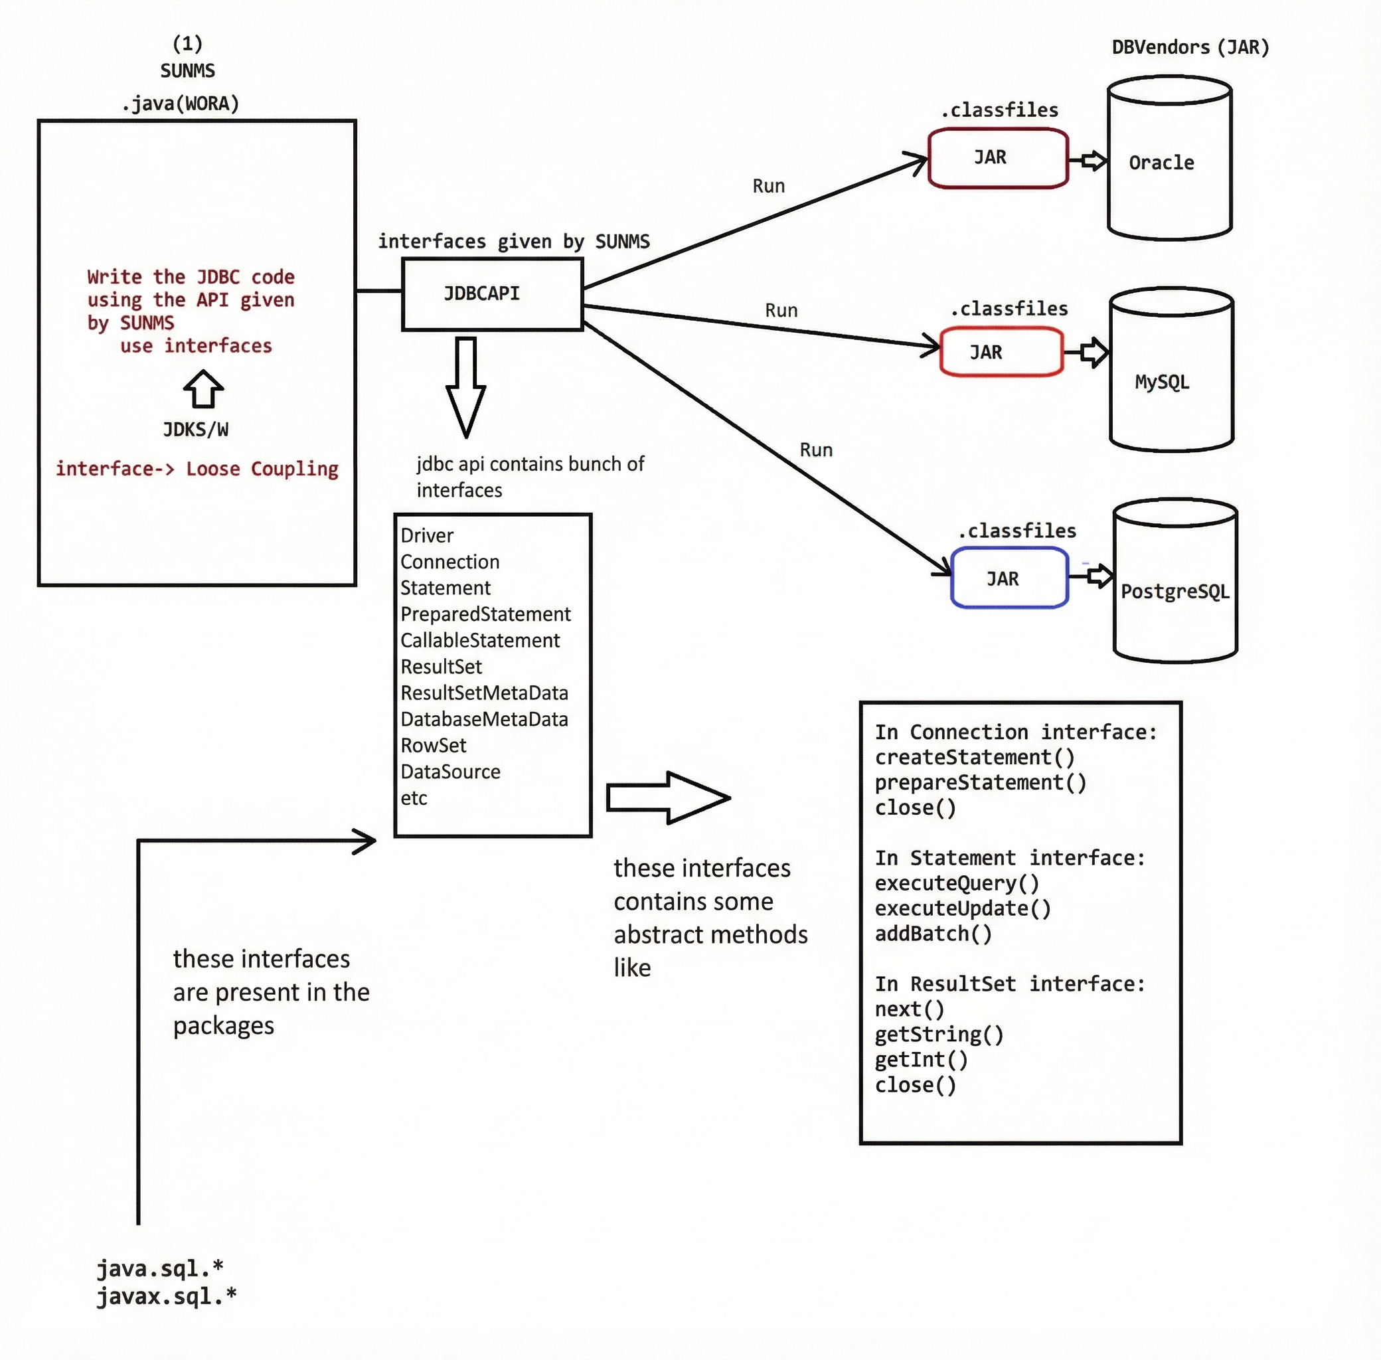

1. Java Program (Your Code)
Look at the left side box.
It says:
.java (Write the JDBC code using API given by SUN)
Use interfaces
Loose Coupling
Meaning
You write a Java program (.java file).
Example:
Connection con = DriverManager.getConnection(url, user, pass);
PreparedStatement ps = con.prepareStatement("select * from student");
ResultSet rs = ps.executeQuery();
But notice something important:
You are using interfaces, not database-specific classes.
Example:
Connection
Statement
PreparedStatement
ResultSet
These come from:
java.sql.*
javax.sql.*
So your code depends on interfaces only.
This is called:
⭐ Loose Coupling
Meaning:
Java Code → JDBC Interfaces
NOT
Java Code → Oracle/MySQL classes
This is a very important design principle in Java.

2. JDBC API (Provided by Sun / Java)
In the center of the diagram you see:
JDBC API
JDBC API contains many interfaces.
Example interfaces:
Driver
Connection
Statement
PreparedStatement
CallableStatement
ResultSet
ResultSetMetaData
DatabaseMetaData
RowSet
DataSource
These interfaces define methods but not implementation.
Example:
Connection interface
Methods:
createStatement()
prepareStatement()
close()
Statement interface
Methods:
executeQuery()
executeUpdate()
addBatch()
ResultSet interface
Methods:
next()
getString()
getInt()
close()
So JDBC API is basically:
A set of rules (interfaces)
But who implements these rules?

3. Database Vendor Drivers (JAR files)
Look at the right side of the diagram.
You see:
Oracle → JAR
MySQL → JAR
PostgreSQL → JAR
These are called:
⭐ JDBC Drivers
Examples:
Database | Driver JAR
Oracle | ojdbc.jar
MySQL | mysql-connector-j.jar
PostgreSQL | postgresql.jar
These drivers implement JDBC interfaces.
Example:
Inside MySQL driver:
class MySQLConnection implements Connection
class MySQLStatement implements Statement
class MySQLResultSet implements ResultSet
Inside Oracle driver:
class OracleConnection implements Connection
class OracleStatement implements Statement
So:
JDBC Interface → Implemented by DB Driver

4. Compilation Stage
When you compile your program:
javac Program.java
Java only checks:
Are JDBC interfaces used correctly?
Because JDBC interfaces are present in:
JDK
So compilation works even without database driver.

5. Runtime Stage
When program runs:
java Program
Now the JDBC driver JAR must be present.
Example:
mysql-connector-j.jar
Then the flow becomes:
Java Program
↓
JDBC Interface
↓
MySQL Driver Implementation
↓
MySQL Database
Or
Java Program
↓
JDBC Interface
↓
Oracle Driver
↓
Oracle Database
So the same program works with multiple databases.

6. Real Flow of Execution
Full flow:
Java Program (.java)
↓
Uses JDBC Interfaces
(Connection, Statement, ResultSet)
↓
JDBC API (java.sql package)
↓
Driver JAR (Oracle/MySQL/PostgreSQL)
↓
Database

7. Why This Design is Powerful
Because of interfaces.
If tomorrow database changes:
MySQL → PostgreSQL
You only change:
Driver JAR
URL
Your Java code remains same.
Example:
Before:
jdbc:mysql://localhost:3306/db
After:
jdbc:postgresql://localhost:5432/db
But the code:
Connection
PreparedStatement
ResultSet
remains same.

8. Loose Coupling (Most Important Concept)
Your program depends on:
Interfaces
NOT on
Database implementation
So:
Java Program
↓
JDBC Interfaces
↓
Driver Implementation
↓
Database
This is called:
⭐ Loose Coupling
This is a very common design pattern in Java frameworks like Spring.

9. One Small Correction in the Diagram
You earlier asked about JDBC position.
JDBC is not a step in execution flow.
Correct understanding:
Java Code
↓
JDBC API (interfaces)
↓
Driver Implementation (JAR)
↓
Database
So JDBC is a bridge between Java and database.

10. One Line Interview Answer
What is JDBC?
JDBC is a Java API that provides interfaces to connect and interact with databases using database-specific drivers.

🌟 JDBC Driver Loading — Super Simple Explanation
1️⃣ The Problem
Your Java program wants to talk to a database (Oracle, MySQL, PostgreSQL).
But Java does not know how to talk to those databases directly.
So every database company provides a JDBC Driver.
Example:
Database | Driver Class
Oracle | oracle.jdbc.driver.OracleDriver
MySQL | com.mysql.cj.jdbc.Driver
This Driver class acts like a translator between Java and the database.

🌟 How Java Finds the Driver Automatically
Inside every JDBC driver JAR file, there are two important things.
Driver JAR
│
├── META-INF
│ └── services
│ └── java.sql.Driver ← text file
│
└── oracle
└── jdbc
└── driver
└── OracleDriver.class
Let's understand them one by one.

🟢 PART 1 — The META-INF File (Name Tag)
File location:
META-INF/services/java.sql.Driver
This file is just a plain text file.
Inside it there is only one line:
oracle.jdbc.driver.OracleDriver
That means:
👉 "The driver class inside this JAR is OracleDriver."
Think of it like this:
📦 JAR file has a name tag
Driver name: oracle.jdbc.driver.OracleDriver
So Java reads this and understands:
"Oh! This JAR contains a JDBC driver."

🟢 PART 2 — The Actual Driver Class
The real driver class is here:
oracle/jdbc/driver/OracleDriver.class
This is the real Java class written by Oracle.
Conceptually it looks like this:
public class OracleDriver implements java.sql.Driver {
static {
DriverManager.registerDriver(new OracleDriver());
}
}
Important points:
✔ It implements java.sql.Driver interface
✔ It contains a static block

🟢 What Happens When Java Loads This Class?
When Java loads the class:
OracleDriver.class
The static block runs automatically.
static {
DriverManager.registerDriver(new OracleDriver());
}
So automatically:
DriverManager
↓
registers
↓
OracleDriver
Now Java knows:
"This driver can connect to Oracle database."

🌟 Complete Flow (Very Simple)
Step 1️⃣
Java looks inside the JAR file
Step 2️⃣
Java finds the file
META-INF/services/java.sql.Driver
Step 3️⃣
Java reads the text:
oracle.jdbc.driver.OracleDriver
Step 4️⃣
Java loads that class
OracleDriver.class
Step 5️⃣
Static block runs
DriverManager.registerDriver()
Step 6️⃣
Driver gets registered.
Now Java can connect to the database.

🌟 Final One-Line Understanding
👉 The META-INF text file tells Java which driver class exists, and when Java loads that class, the driver registers itself automatically using a static block.

🌟 One Small Modern JDBC Note (Important)
In old JDBC (before Java 6) we had to write:
Class.forName("oracle.jdbc.driver.OracleDriver");
But in modern JDBC, Java automatically finds the driver using the META-INF/services/java.sql.Driver mechanism.
So manual loading is usually not needed anymore.

